



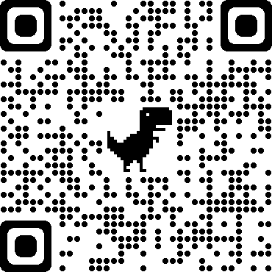

Enter Supervisor Photo Here





The Center for Career Readiness

**About Me:**

Share a short paragraph about your accomplishments.  
   
**Fun Facts:**

List three fun facts about you.