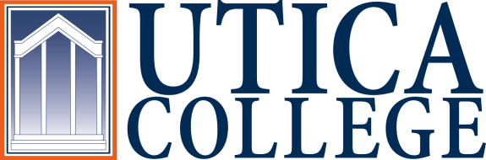

INSTITUTIONAL EFFECTIVESS COMMITTEE
AGENDA

September 6, 2018
11:30 a.m. – 1:00 p.m.
IITS Conference Room

1. Welcome and introductions
2. Role of the Institutional Effectiveness Committee
3. Institutional priorities (Kim Lambert)
- What is the IEC’s role in institutional assessment?
4. Student learning assessment: update & next steps
5. Assessment of administrative departments
- What should the “semi-annual” report look like?
- 5-year program review: requirements, process, and format
6. Maintaining roadmaps and documenting continuous improvement
7. Performance indicators
8. Meeting schedule
9. Other?

To call in to the meeting from off-campus, please dial 315-792-4555. The conference number is 2568 followed by the # key.

