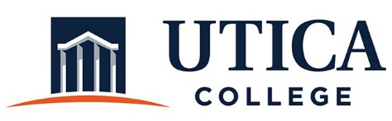

INSTITUTIONAL EFFECTIVESS COMMITTEE
AGENDA

September 25, 2018
11:15 a.m. – 12:30 p.m.
IITS Conference Room

1. Approval of minutes from September 6, 2018
2. October meeting schedule: Change to October 16 and October 30
(October 9 is Fall Break; October 23, Ann will be at assessment conference.)

3. TaskStream demonstration

4. Reviewing models of assessment reports and program reviews for administrative units
- Boston College
- Norco College
- Pepperdine U
- Sam Houston U
- University of Notre Dame
- West Carolina

5. Other

To call in to the meeting from off-campus, please dial 315-792-4555. The conference number is 2568 followed by the # key.

