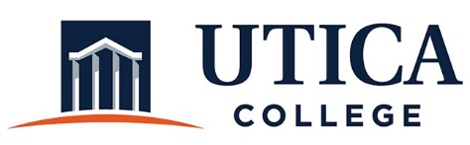

INSTITUTIONAL EFFECTIVESS COMMITTEE
Meeting Agenda

September 24, 2019
11:15 a.m. – 12:30 p.m.
Thurston Conference Room (T101A)

- Approval of minutes from September 10, 2019
- Review of assessment plans from the following departments: Diversity, Equity, and Inclusion; Learning Services; International Education; and the Library/Learning Commons.
- Other

To call in to the meeting from off-campus, please dial 315-792-4555. The conference number is 2568 followed by the # key.

