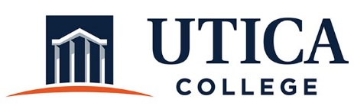
CO-CURRICULAR ASSESSMENT COMMITTEE
AGENDA
October 8, 2019
8:30 a.m. – 9:30 a.m.
Center for Student Success Conference Room

- Approval of minutes from September 10, 2019
- Update on handbook, website, and rubric
- Update on IEC review of assessment plans from Co-Curricular units
- Strategies for 2019-2020
- Communication plan
- Assessment showcase
- Appointment of assessment liaisons
- Other

