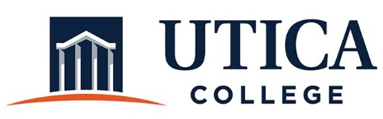

INSTITUTIONAL EFFECTIVESS COMMITTEE
Meeting Agenda

October 22, 2019
11:15 a.m. – 12:30 p.m.
Thurston Conference Room (T101A)

- Approval of minutes from October 8, 2019
- Review of assessment plan from Undergraduate Admissions (Stephanie Nesbitt and Ann Damiano)
- Progress on independent reviews
- Sharing rubrics with supervisors
- Process for assessing/reporting on student success model
- Models for reporting on strategic plan/dashboards
- Other

To call in to the meeting from off-campus, please dial 315-792-4555. The conference number is 2568 followed by the # key.

