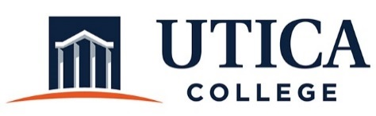

INSTITUTIONAL EFFECTIVESS COMMITTEE
AGENDA

October 16, 2018
11:15 a.m. – 12:30 p.m.
IITS Conference Room

1. Approval of minutes from September 25, 2018
2. RPK Explanation—Matt Carr

3. Process for reporting on institutional initiatives

4. Reviewing models of assessment reports and program reviews for administrative units
- Pepperdine U
- University of Notre Dame
- West Carolina
- Chapel Hill
- Western Carolina

5. Other

To call in to the meeting from off-campus, please dial 315-792-4555. The conference number is 2568 followed by the # key.

