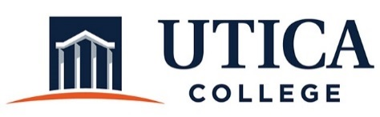

INSTITUTIONAL EFFECTIVESS COMMITTEE
AGENDA

November 6, 2018
11:15 a.m. – 12:30 p.m.
IITS Conference Room

1. Approval of minutes from October 30, 2018
2. Review of administrative program review template, departments responsible for assessment, and the administrative program review process.

3. “Leftover” items from October 16

4. Annual assessment reports, overarching assessment process, alignment with budget and performance review

5. Other

To call in to the meeting from off-campus, please dial 315-792-4555. The conference number is 2568 followed by the # key.

