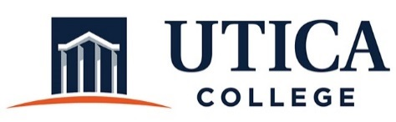

INSTITUTIONAL EFFECTIVESS COMMITTEE
AGENDA

November 20, 2018
11:15 a.m. – 12:30 p.m.
IITS Conference Room

1. Approval of minutes from November 6, 2018
2. Conversation with Lisa Green regarding performance reviews and performance goals

3. Review of self-study template and Guide to Annual Assessment and Program Review: Co-Curricular and Non-Academic Departments”

4. Draft of IEC Fall 2018 Report to the College President

5. Other

To call in to the meeting from off-campus, please dial 315-792-4555. The conference number is 2568 followed by the # key.

