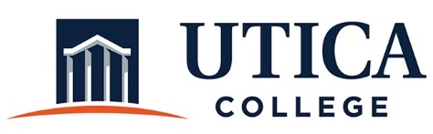

INSTITUTIONAL EFFECTIVESS COMMITTEE
Meeting Agenda

November 19, 2019
11:15 a.m. – 12:30 p.m.
Thurston Conference Room (T101A)

- Approval of minutes from November 12,2019
- Models for reporting on strategic plan/dashboards
- Other

To call in to the meeting from off-campus, please dial 315-792-4555. The conference number is 2568 followed by the # key.

