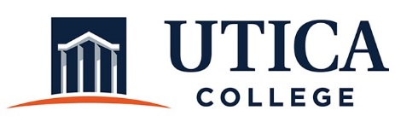

Minutes
January 15, 2019
11:15 a.m. – 12:20 p.m.
IITS Conference Room

Present: Ann Damiano (Chair), Matt Carr, Kim Lambert, Deanna Errico, Wendy Moore, Erin Knight, Halina Lotyczewski, James Scannell, Carl Lohmann, and Stephanie Nesbitt

1. The minutes from December 4, 2018 were approved as written.

2. The guide for the 5-year program review for administrative departments and the program review template were shared with the President and the Joint Cabinet. Members of the Joint Cabinet were asked to provide Ann Damiano with suggested revisions by January 11, 2019. Jeff Gates updated the various offices in his area. One reviewer noted that the guide used the terms “program,” “department,” “operation,” and “unit” synonymously and suggested that a consistent vocabulary be employed. The IEC agreed that we would use the word “department.” Ann Damiano said she would make those revisions to the document.

3. The committee discussed the program review schedule. As discussed previously, departments need to start doing annual assessments before they can complete a reflective program review. A number of departments in Student Affairs have been engaged in annual assessments for two years, so the committee agreed those departments should be among the first ones to complete a program review. Members concurred that 2023-2024 will be the first year program reviews will be scheduled. Ann Damiano will draft a schedule for the committee to review at its next meeting.

The committee estimated that approximately 9 reviews would be completed per academic year. Two members of the IEC will be assigned to each report. It is likely that the reports from the co-curricular units in Academic Affairs, Athletics, and Student Affairs will be reviewed by the Co-Curricular Assessment Committee.

4. In 2021-2022, the IEC needs to recommend to the President that the College has an assessment budget for program reviews/external teams, implement procedures for how departments will request funds, and re-evaluate the current stipend of $500 per department.

5. The IEC needs to articulate a clear process for the annual assessment reports from administrative departments. The report requirements will be consistent with what is common to an assessment report: mission, goals, assessment methods, findings, action plans, and resource needs. This template will be built into TaskStream, and Ann Damiano will schedule professional development during the summer of 2019.

The process for when reports will be due and how they will be reviewed needs to be developed. This process should be consistent with what is expected in other areas of the College. Ann Damiano agreed to draft a process for the IEC to review at its next meeting. She will also create a rubric for reviewing these report.

6. The IEC reviewed the draft of the resource guide. Ann Damiano will add the section on TaskStream, and Matt Carr will write a section on how to develop and select good assessment tools. Additional resources will be added to this guide when they become available. Examples include the review rubric and samples of exemplary reports.

7. Ann Damiano will contact Pam Salmon about meeting with the committee regarding budgeting processes and how assessment might align with them.

8. The committee will meet again on Tuesday, January 29, 2019.

9. The meeting adjourned at 12:20 p.m.

Respectfully submitted,

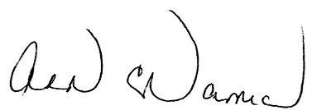

Ann Damiano

