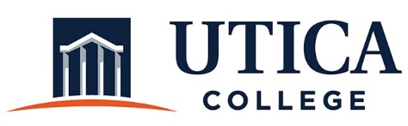

INSTITUTIONAL EFFECTIVESS COMMITTEE
Meeting Agenda

March 24, 2020
11:15 a.m. – 12:30 p.m.
Hangouts Meet

- Approval of minutes from March 10, 2020
- Continued review of self-study recommendations
- Review of mission statement for the Office of Institutional Effectiveness
- Assessment of Assessment: Three-Year Schedule
- Other

To call in to the meeting from off-campus, please dial 315-792-4555. The conference number is 2568 followed by the # key.

