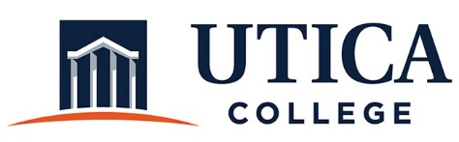

INSTITUTIONAL EFFECTIVESS COMMITTEE
Meeting Agenda

March 10, 2020
11:15 a.m. – 12:30 p.m.
ECJS 209

- Approval of minutes from February 25, 2020
- Updates: Implementation Plan for the Strategic Plan
- Update on membership for 2020 - 2021
- Middle States self-study recommendations
- Professional development-administrative operations
- Other

To call in to the meeting from off-campus, please dial 315-792-4555. The conference number is 2568 followed by the # key.

