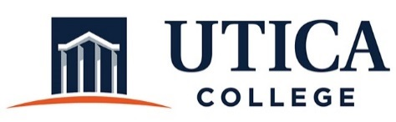

INSTITUTIONAL EFFECTIVESS COMMITTEE
AGENDA

January 29, 2019
11:15 a.m. – 12:30 p.m.
IITS Conference Room

1. Approval of minutes from January 15, 2018

2. Update on revisions made to the Guide to Annual Assessment and Program Review: Co-Curricular and Administrative Departments.

3. 5-year program review schedule for administrative departments

4. Process for the annual assessment reports

5. Rubric for annual assessment reports and Institutional Effectiveness

6. Other

To call in to the meeting from off-campus, please dial 315-792-4555. The conference number is 2568 followed by the # key.

