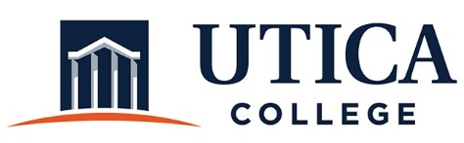

INSTITUTIONAL EFFECTIVESS COMMITTEE
Meeting Agenda

January 28, 2020
11:15 a.m. – 12:30 p.m.
Thurston Conference Room (T101A)

- Greetings and welcome back
- Approval of minutes from November 19, 2019
- Review of action plan for Spring 2020
- Process for assessing and reporting on the strategic plan
- Update on meeting with Kelly Adams and team
- Feedback from Joint Cabinet
- Implementation plan: Who is doing what?
- Integration with Academic aster Plan, Enrollment Plan, DEI Operational Plan, Capital Projects/Master plan, and annual departmental assessment plans/reports
- Strategies to include and assess ROI
- Other

To call in to the meeting from off-campus, please dial 315-792-4555. The conference number is 2568 followed by the # key.

