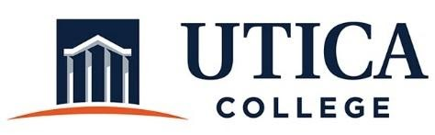
INSTITUTIONAL EFFECTIVENESS COMMITTEE

September 1, 2020
11:15 a.m. – 12:30 p.m.
- Approval of minutes from April 21, 2020 (with correction to a misspelling under item 4: “spring” report, not “soring” report)
- Introduction of Kristin Haag
- Observations about 2019 -2020 assessment reports
- Next steps—2020 – 2021 assessment planning: What to communicate? How to report?
- Survey on assessment review process: Summary of results
- Update on strategic plan report
- Guide to Institutional Effectiveness: 2020 – 2021
- External reviewers for administrative program reviews
- Revised program review schedule
- IEC 2020 – 2021 action plan (See “May 2020 Summary Report”)
- Other

