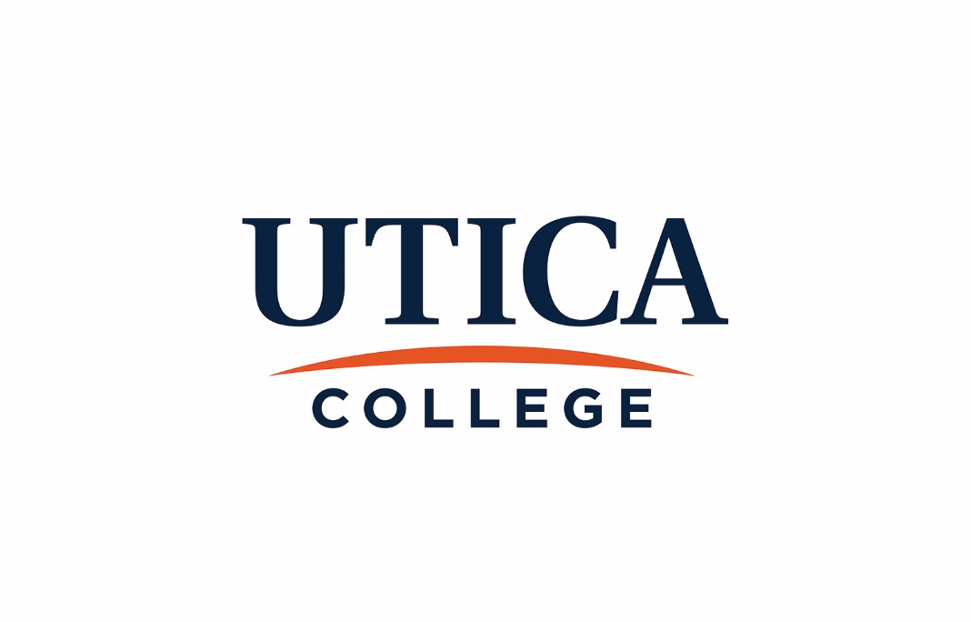

GUIDE TO ACADEMIC ASSESSMENT

2017- 2018

Principles of Good Assessment

Assessment processes at Utica College are guided by accreditation standards and best practices. Consistent with the guiding principles articulated in “Assessing Institutional Effectiveness at Utica College,” academic assessment is
- Governed by the faculty
- Relevant and realistic
- Systematic, ongoing, and connected to the institutional mission
- Well-planned
- Well-documented, and
- Student-centered

Effective assessment processes are characterized by the following:

- They use multiple methods to assess each individual goal.
- They rely primarily on direct evidence; indirect evidence is used to supplement the narrative.
- They provide specific evidence regarding areas of strength and areas needing improvement.
- They produce results that are useful to planning and resource allocations.
- They are shared with and analyzed by all relevant stakeholders.

Who Is Required to Do Assessment?

Student Learning
All academic programs and departments are expected to assess student learning and operational goals on an annual basis. Each program/department must complete its report using the annual program goal report form. Reports are to be submitted to the respective school dean no later than August 15. The school deans are responsible for submitting approved reports to the Academic Assessment Coordinating Committee.

Academic programs and departments are likewise required to complete a 5-year program review. Programs scheduled for review must submit a copy of their self-study to the Academic Assessment Coordinating Committee by October 15 of the review year. In cases where a program is subject to external accreditation the program may elect to use that self-study for their program review, accompanied by an executive summary and additional documentation, if necessary.

Administrative operations dedicated to student services and support also complete an annual report on student learning goals. These units include athletics, offices in Student Services, and the Office of Learning Services. Reports from these units are submitted to the Student Services Assessment Coordinating Committee.

All assessment documents are to be submitted to the following email: assessment@utica.edu.

Administrative Departments
Heads of administrative departments, including the Frank E. Gannett Memorial Library, the Registrar, Graduate Studies, and the E. Barrett Art Gallery, establish annual goals for their operations through the annual performance review process. In addition, these units are responsible for meeting the divisional goals established annually by the Provost’s Cabinet. At a mid-year and summer retreat, cabinet members report on the progress made towards achieving the divisional goals.

Assessment Processes and Expectations

Student Learning
Student learning assessment is organized around student learning goals at the institutional and programmatic levels, and learning objectives at the course-specific level.
Course-level learning objectives are expected to be clearly articulated in each syllabus and congruent with program-level learning goals. Current curriculum maps, required for each program, show the degree to which courses in the major support the program-level learning goals. The school deans and/or program directors and chairpersons review syllabi to ensure compliance with this requirement.
Program-level student learning goals are regularly assessed based on the program’s assessment plan. All goals should be assessed at least once in a 5-year review cycle, but best practice recommends assessing each goal twice during the review cycle. Direct methods must be used to assess student learning. Indirect methods may be used to supplement findings. Student learning assessment processes and results are documented in an annual report and submitted to the respective school dean. It is expected that the majority of faculty in a program will participate in the assessment process, from administering the assessments to interpreting the results and generating an action plan. Efforts should be made to include adjunct faculty in the process. When warranted, results should be shared with other stakeholders, such as students or alumni.
The school dean, upon receiving the assessment reports, will meet with the programs/departments to discuss the assessment results and action plans. Likewise, the Dean of Assessment will serve as a resource to faculty, reviewing assessment processes and making recommendations to ensure sustainability and usefulness.
Once the school dean is satisfied with the annual program assessment report, he or she will submit a copy electronically to assessment@utica.edu. The report will be reviewed by the Academic Assessment Coordinating Committee (AACC) who will determine the extent to which the program is in compliance with institutional requirements and accreditation standards.
Institution-level student learning refers to the college’s five (5) intellectual skills and the learning goals associated with the Core curriculum. The 5 intellectual skills are assessed in both the curricular and co-curricular experiences. Academic programs/departments and co-curricular units document results on an annual basis in their assessment reports. The Oversight Committee for Core (OCC), chaired by the Director of Core, administers the student learning assessments for the Core program. Core Leadership Groups, comprised of teaching members of the faculty, plan and conduct the assessments and review the results. The director reports directly to the Provost, and OCC reports to the Faculty Senate.
Indirect assessments of student learning and institutional effectiveness are additionally conducted by the Office of Institutional Research. Such measures include the National Survey of Student Engagement (NSSE), the Noel-Levitz Student Satisfaction Inventory (SSI), and the Student Opinion of Teaching survey. The NSSE and SSI results may be found at https://www.utica.edu/ir/studentsurveys.cfm.
Five-year program reviews require all academic programs to complete a self-study. The self-study asks faculty to reflect on and analyze data related to student learning, curriculum, faculty qualifications, and program resources. A content outline specifies the information that needs to be included in the self-study.

Programs scheduled for review must submit a copy of their self-study to their school dean by October 1 of the review year. The dean is responsible for reviewing the report and ensuring it meets institutional requirements. No later than October 15, the dean must submit the self-study report to the Academic Assessment Coordinating Committee at assessment@utica.edu. The Academic Assessment Coordinating Committee will review the reports and provide written feedback to the school dean and the program faculty based on clearly articulated criteria. The committee’s comments will likewise be shared with the Provost. The Provost, in turn, will meet with the program faculty to discuss the review, the program’s goals, and an action plan for achieving these goals.

Some academic departments include more than one registered program. If a department would like to consolidate the program review process and include more than one program in the department, a request should be made in writing and forwarded to the Academic Assessment Coordinating Committee. This request must be submitted the spring prior to the deadline for submission.

For programs that have specialized accreditors, the accreditation reports may replace the self-study. If a program wishes to use an accreditation report, it must first seek approval from AACC. This request should be made in writing to the Dean of Assessment the spring prior to the self-study deadline. If this substitution means a change in the program review schedule, this should be indicated to the AACC.

In the likely event that the accreditation report substitutes for the self-study, the program will be required to submit a copy of their accreditation reports to the Academic Assessment Coordinating Committee. In addition to this report, they should submit a brief executive summary that elucidates where in the accreditation documents the answers to the College’s questions may be found. If the accreditation document does not address one or more of the College’s questions, additional documentation is required. Finally, the program must still submit the program goals form outlining the department’s goals, including student learning goals, and meet with the Provost to discuss the accreditation report, team visit report, and program goals.

Operational Effectiveness
Academic Assessment at Utica College focuses on both operational effectiveness at the division and program level and student learning at the institutional, programmatic, and course-specific levels. Division-level operational effectiveness assessment is carried out in response to the goals established by the Provost’s cabinet, while program-level operational effectiveness assessment responds to operational goals established by individual academic programs. The assessment is carried out by various offices and programs reporting through Academic Affairs; information is disseminated in regular reports and utilized in decision making.
Sharing Assessment Results
Program-level assessment results, whether related to student learning or operational effectiveness, are shared with the Academic Assessment Coordinating Committee as part of the committee’s annual review process. The committee uses this information to assess the institution’s assessment processes and identify faculty development needs. The Academic Assessment Coordinating Committee reports twice a year on the status of assessment at Utica College.
Program-level assessment results are also shared with and reviewed by faculty members. In each school, programs or departments schedule retreats each summer in order for faculty to review and interpret recent assessment findings and develop plans of actions based on these results. Departmental faculty also meet prior to the beginning of each term to discuss ways to implement the action plans and to finalize the assessment strategies for the upcoming semester.
Institutional assessments of student learning are managed by the Oversight Committee for Core. Results are reviewed by the faculty who teach in the Core program and reported to the Faculty Senate. Assessment results of Core goals and the 5 intellectual skills are also posted on the college’s website and may be accessed by any member of the Utica College community. Institutional survey data from NSSE and SSI are likewise posted and may be accessed on the Office of Institutional Research webpage (https://www.utica.edu/ir/studentsurveys.cfm).
With all learning assessments, assessment data remains confidential and is reported only in aggregate form at the program level. All electronic data is secured by limiting access to the password protected files.
The privacy of both students and faculty is protected, and unless the assessment is also an assignment in a course, student performance in the assessment activity does not affect course grades or progress toward graduation.
Oversight of Student Learning Assessment Processes

The Utica College Assessment Steering Committee provides institutional oversight of college-wide assessments of student learning goals, both curricular and co-curricular. Chaired by the Provost, this committee further oversees assessments of all programs, departments, and services.
The Academic Assessment Coordinating Committee (AACC), chaired by the Dean of Assessment, coordinates the assessment procedures within the division of Academic Affairs, including the 5-year program review and the departmental annual assessment report. This committee is responsible for periodically assessing the assessment processes and determining how useful and effective they are. AACC reports directly to the Provost and generates semi-annual reports of the status of assessment at Utica College.
The Oversight Committee for Core manages the assessment processes of the Core goals, which include the 5 intellectual skills associated with general education. This committee is chaired by the Director of Core.
Assessment processes in Student Service units and other administrative operations integral to the educational experience at Utica College are monitored by the Student Services Assessment Coordinating Committee. This committee is co-chaired by the Dean of Students and the Dean for Diversity.
Connecting Assessment to Planning and Budgeting

Through the annual goal report process, departments and programs indicate action plans based on assessment and other data sources and indicate resource needs. Program directors and/or deans then meet with their supervisor to review their goals, action plans, and resource needs. In the event that the resource needs have budget implications and are endorsed by the supervisor, the request is brought by the supervisor to the budget oversight committee and reviewed during budget proceedings.
Budget decisions are made with respect to assessment data, compliance regulations, risk management, professional standards, and institutional priorities.

Glossary of Terms
Academic Program – According to NYS Education Department, an academic program is organized around the set of educational requirements necessary to qualify for a registered degree. The curriculum or program includes general education or specialized study in depth in a particular field, or both (NYSED, 2012).
Artifacts – The work produced by students while engaged in a learning experience.
Analysis of Findings - Examination of the data gathered during the assessment cycle, including reflective consideration about what actions, if any, should be taken.
Action Plans - Actions taken to improve the program or assessment process based on the analysis of results; “Closing the loop.”
Assessment – The measure of the extent to which goals have been met; provides specific evidence of strengths and areas needing improvement.
Assessment process – The systematic collection, review, and use of information about student learning, educational programs, student support programs, and college services undertaken to improve teaching/learning and institutional effectiveness.
Assessment Plan - A document which outlines how and when selected outcomes will be assessed.
Assessment Report - An annual document based on the Assessment Plan that presents and explains assessment results and shows how assessment results are being used to improve the program.
Benchmark - A standard or point of reference against which things may be compared or assessed.
Course-embedded Assessments – Direct methods to assess student-learning that are well integrated into and organic to the educational experience.
Course Student Learning Goals (CSLG) – the measurable learning/knowledge/skill expectations for all students completing an academic course, documented in the syllabi and program review documents. Direct measures are to be used; indirect measures/results will be used to support the direct measure findings. CSGL are identified by faculty, described in the course syllabus, and it is the faculty of each course who determine what to measure and the tool to use for this faculty-driven process.
Course Operational Goals –focus on the functioning of the course, rather than the learning achieved by the students. Examples include development of new courses, deletion of a course, edits to a course, and course mapping to program goals.
Course Syllabus – A document that lays out the expectations, including the learning goals, for a single course.
Curriculum Map – A matrix representing a program's learning goals and indicating where they are developed in a program and to what extent.
Direct Methods of Assessment – Measures used to document student performance. Examples of direct measures include rubrics for capstone projects, portfolios, papers, and performances.
Findings - Results (evidence, data and/or information) gathered from assessment.
Formative Assessments – Assessments that occur throughout the learning process that aim to understand and, therefore, improve learning.

Indirect Methods – Measures used to assess students' perceptions of their learning and educational experiences. Examples of indirect measures include surveys, focus groups, and interviews.

Institutional Priorities –In consultation with the Board of Trustees the college President identifies the College’s institutional priorities for the year. All goals are linked directly to the College’s Strategic Plan and are executed at the Divisional level. Independent divisional goals may also sometimes inform and direct new strategic initiatives or institutional goals through the established strategic planning processes.

Institutional Student Learning Goals – The measurable student learning goals that are realized in the complete educational experience, both curricular and co-curricular. At Utica College, the key intellectual skills are the institutional learning goals.

Mission Statement - A concise statement outlining the purpose of a program, who it serves, and what distinguishes it.

Program Student Learning Goals (PSLG) – the measurable learning/knowledge/skill expectations for all students graduating from a particular curriculum/major or students being served by a particular unit.

Program Operational Goals – Goals set for and by a program, usually during the 5-year program review process. However operational goals may be set during a review for an external accreditor or in the interim between program reviews. Operational goals address the functioning of the program.
Program Review – required self-study process completed by each academic program. It is usually conducted on a five-year rotation, unless external program accreditation cycles require a different review time line.

Rubric - Specific sets of criteria that clearly define for both student and teacher what a range of acceptable and unacceptable performance looks like. Criteria define descriptors of ability at each level of performance and assign values to each level.

Target - A value that indicates whether or not a goal has been achieved.

Validity - The extent to which an assessment measures what it is supposed to measure and the extent to which inferences and actions made on the basis of test scores are appropriate and accurate.

Value added – Evidence that shows the effects educational providers have had on students during their programs of study beyond what would have occurred through natural maturation. A comparison of the knowledge and skills students bring to the educational process with the knowledge and skills they demonstrate upon completion of the educational process.

Program Review Schedule: 2017 - 2019

2017

Program Title | Award | PR due
CHEMISTRY | BS | 8/15/2017
HISTORY | BA | 8/15/2017
COMPUTER SCIENCE | BS | 10/15/2017
CRIMINAL JUSTICE | BS | 10/15/2017
PHILOSOPHY | BA | 10/15/2017
PSYCHOLOGY - CHILD LIFE | BS | 10/15/2017
SOCIOLOGY-ANTHROPOLOGY | BA | 10/15/2017

2018
Program Title | Award | PR due
BIOLOGY (including Animal Behavior, Neuroscience, and Psychobiology) | BS | 10/15/2018
GEOSCIENCES | BA & BS | 10/15/2018
PHYSICS | BA & BS | 10/15/2018
FOREIGN LANGUAGE | BA | 10/15/2018
CYBERSECURITY | BS | 10/15/2018
EDUCATION | BA, BS, MS & MSED | 10/15/2018
PHYSICAL THERAPY (PPtDPT) | DPT | 10/15/2018
PROFESSIONAL ACCOUNTING, MANAGEMENT, AND ECONOMIC CRIME AND FRAUD MANAGEMENT | MBA | 10/15/2018
ACCOUNTING, BUSINESS ECONOMICS, AND BUSINESS MANAGEMENT | BS | 10/15/2018

2019
Program Title | Award | PR due
ECONOMICS | BA | 10/15/2019
FINANCIAL CRIME & COMPLIANCE MANAGEMENT | MS | 10/15/2019
MATHEMATICS | BA | 10/15/2019
THERAPEUTIC RECREATION | BS | 10/15/2019

Notes

