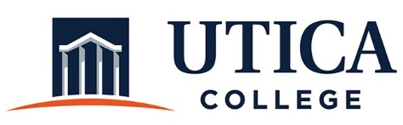

INSTITUTIONAL EFFECTIVESS COMMITTEE
Meeting Agenda

February 25, 2020
11:15 a.m. – 12:30 p.m.
Thurston Conference Room (T101A)

- Approval of minutes from February 11, 2020
- Guest: Fran Vescio to discuss elements of an implementation plan
- Updates
- Other

To call in to the meeting from off-campus, please dial 315-792-4555. The conference number is 2568 followed by the # key.

