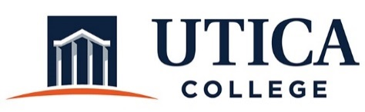

INSTITUTIONAL EFFECTIVESS COMMITTEE
AGENDA

February 12, 2019
11:15 a.m. – 12:30 p.m.
IITS Conference Room

1. Approval of minutes from January 29, 2019

2. Budgeting and Resource Allocation: Pam Salmon, guest

3. Annual Performance Review process (see Guide to Institutional Effectiveness)

4. Assessment workshops and professional development

5. Rubrics

6. Other

To call in to the meeting from off-campus, please dial 315-792-4555. The conference number is 2568 followed by the # key.

