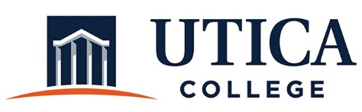

INSTITUTIONAL EFFECTIVESS COMMITTEE
Meeting Agenda

February 11, 2020
11:15 a.m. – 12:30 p.m.
Thurston Conference Room (T101A)

- Approval of minutes from January 28, 2020
- Update on persons responsible for SP implementation
- Process for gathering information on SP
- Timeline
- Types of evidence
- Reporting format: How to collect the information
- Updating the Guide
- Other

To call in to the meeting from off-campus, please dial 315-792-4555. The conference number is 2568 followed by the # key.

