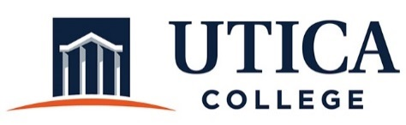

INSTITUTIONAL EFFECTIVESS COMMITTEE
AGENDA

December 4, 2018
11:15 a.m. – 12:30 p.m.
ECJS 209

1. Approval of minutes from November 20, 2018
2. Final review and approval of President’s report, program review template, and program review guide.

3. Town Hall presentation

4. Meeting times for Spring 2019

5. Other

To call in to the meeting from off-campus, please dial 315-792-4555. The conference number is 2568 followed by the # key.

