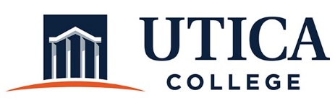
CO-CURRICULAR ASSESSMENT COMMITTEE
AGENDA
December 3, 2019
12 noon
White 122A

- Approval of minutes from October 30, 2019
- Showcase update and timeline
- Liaison outreach: January 2020
- Other

