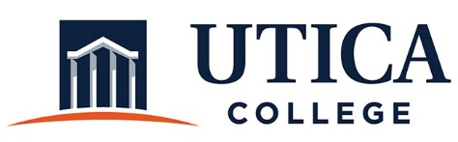

INSTITUTIONAL EFFECTIVESS COMMITTEE
Organizational Meeting Agenda

August 26, 2019
10:00 a.m. – 12 noon
Thurston Conference Room (T101A)

- Revisions to website and Guide to Institutional Effectiveness
- Update on administrative assessment efforts
- Process for reviewing 2019-2020 assessment plans
- Program review template: Adding question on diversity
- Assessment of strategic initiatives
- Student Success metrics
- IEC action plan for 2019-2020
- MSCHE standards and recommendations
- Integration of the strategic plan
- Integrating IEC, AACC, and Co-CA
- Meeting times: 2019-2020
- Other

To call in to the meeting from off-campus, please dial 315-792-4555. The conference number is 2568 followed by the # key.

