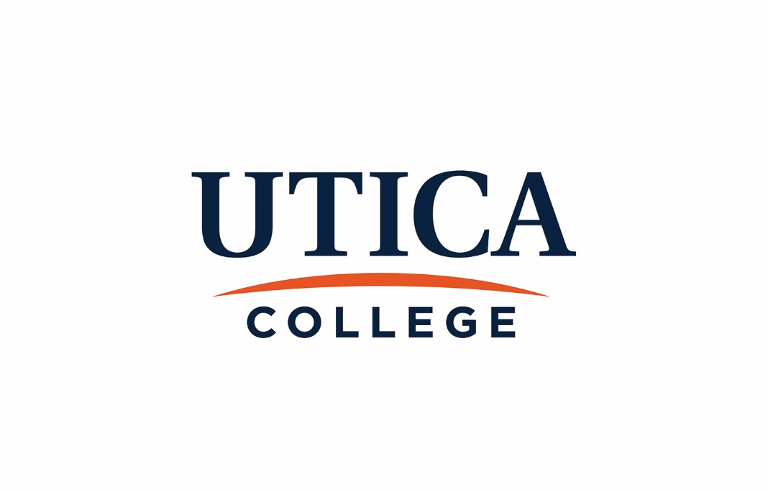

Academic Assessment Coordinating Committee

Handbook
Policies and Procedures

2017 - 2018

Revised August 2017
Table of Contents

Academic Assessment Coordinating Committee
Function and Authority…………………………………………………………………………..3
Membership……………………………………………………………………………………...3
Officers…………………………………………………………………………………………..3
Records…………………………………………………………………………………………..4
Records Retention………………………………………………………………………….…….4

Assessment Processes
Departmental Annual Goals and Student Learning Assessment………………………………..5
The 5-Year Program Review Process…………………………………………………………...5
Institutional Learning Goals…………………………………………………………………….7

Academic Assessment Coordinating Committee (AACC)

Responsibility and Authority
The Academic Assessment Coordinating Committee (AACC) oversees academic assessment within the Division of Academic Affairs at the program and institutional level.

The committee’s responsibilities are as follows:

- Review academic assessment mechanisms and recommend any necessary changes to the Office of the Provost, which has oversight responsibility for all academic assessment at Utica College.
- Review, provide evaluative feedback on, and ultimately approve program assessment plans.
- Review, provide evaluative feedback on, and ultimately approve 5-year program reviews.
- Review, provide evaluative feedback on, and ultimately approve departmental annual goal reports.
- Recommend to the Provost specific actions that need to be taken in light of reviewing assessment documentation.
- Review and provide evaluative feedback on all-college assessment of student learning conducted by academic affairs.
- Generate semi-annual reports on the status of assessment activities to be shared with the faculty and academic administration.

The AACC has the authority to approve or not approve documents submitted to it and to require corrective action where necessary. The AACC works with the Provost to determine appropriate specific actions to be taken in light of reviewing assessment documentation.

Membership

Membership of the AACC consists of
- The Dean of Assessment (Chair)
- The Associate Provost
- The Associate Provost for Online Education
- One librarian
- Three (3) faculty members from each school
Faculty members are appointed to the committee by their respective deans. At least one faculty member must be tenured, and each serves a 3-year term with no term limits. All AACC members are voting members.
Officers

The Dean of Assessment serves as chair of the AACC and is responsible for
- Setting the agenda for AACC meetings and distributing the agenda in advance of the meetings
- Chairing the AACC meetings
- Generating semi-annual reports on the state of assessment

-3-
- Coordinating communications btween the AACC and academic programs or departments
- Updating the AACC Handbook, the Guide to Academic Assessment, and all webpages related to academic assessment at Utica College

The Dean of Assessment is additionally responsible for facilitating the program review process in concert with the school deans and the Director of Institutional Research; working closely with faculty, academic departments, the Overight Committee for Core, the Vice Provost for Online Education, and any administrative units responsible for assessing student learning to develop processes that are valid, reliable, sustainable, and useful; maintaining electronic records of assessment documents; identifying and facilitating faculty and staff development needs; and promoting a culture of assessment at Utica College.

A secretary of AACC will be appointed annually to record and distribute minutes.

Records

The Committee’s official records will be stored on the College’s designated storage devices. Given the possible confidential nature of the program reviews and assessment reports, these documents, and any accompanying communications regarding their contents, will be maintained by the Dean of Assessment, and only AACC members and the Provost will have access to them. Other Utica College stakeholders who wish to review assessment documents should contact the Dean of Assessment.

Committee agendas and minutes will be posted on the College’s server in a designated folder and made accessible to any member of the Utica College community.

AACC reports to the faculty and Provost on the state of assessment at Utica College will be posted on the committee’s webpage and protected by password.

Records Retention

Committee agendas, minutes and related materials will be kept for a minimum of ten years and may be deleted after that period at the discretion of the committee. Assessment documentation (including program reviews, communications with programs, and reports) are permanent records of Utica College and will be retained accordingly.

-4-

Assessment Processes

Departmental Annual Goals and Student Learning Assessment

All academic programs and departments should have clearly articulated student learning goals and operational goals related to students or the program’s effectiveness. Student learning goals must be posted on the department’s website and visible to all stakeholders, including current students, prospective students, parents, and accrediting agencies.

The annual assessment of program goals is part of the 5-year program review process. Each program/department is required to assess student learning and operational goals on an annual basis, as outlined below.

- The program director or his/her designee completes an annual goal report on program-level learning assessments and submits to the appropriate school dean by August 15. At the same time, the program’s curriculum map should be reviewed to ensure that students have sufficient opportunities to achieve the learning outcomes in their majors. The curriculum map checklist will assist faculty in their review of curriculum maps.
- The school dean will submit the annual report on student learning to the AACC at the following address: assessment@utica.edu.
- The AACC will review the annual goal reports provide summative feedback to the school deans and program/departmental faculty.
- Any follow-up to the annual report review will be facilitated by the Dean of Assessment in concert with the program director or department chair and school dean.
- Aggregated information derived from these reports may be included in the semi-annual reports from the committee.

The 5-Year Program Review Process

Academic programs at Utica College conduct ongoing, systematic assessments of student learning and program effectiveness to inform curriculum structures and design, pedagogy, program planning and resources, and budget decisions.

The program review process affords faculty the opportunity to

- Reflect on assessment findings gathered during a 5-year review period
- Engage in candid and deliberate discussions related to the past, present, and future of the program
- Re-envision ways the program supports Utica College’s mission to educate students for rewarding careers, responsible citizenship, and fulfilling lives by integrating liberal and professional study.

Program reviews are due in the fall of the academic year, usually five years after the committee completed its deliberation of the prior review. The program review schedule is established by the AACC and posted on the assessment website.

-5-
Some academic departments include more than one registered program. If a department would like to consolidate the program review process and include more than one program in the department, a request should be made in writing and forwarded to the Academic Assessment Coordinating Committee. This request must be submitted the spring prior to the deadline for submission.

In cases where a program is subject to external accreditation the program may elect to use that document for their program review. In order to do so, the program must

- Seek approval from AACC before using the external accreditation report and, if necessary, delaying the program review to coincide with the external accreditation.
- Submit an executive summary that elucidates where in the accreditation documents the answers to the College’s questions may be found. If the accreditation document does not address one or more of the College’s questions, additional documentation may be required.
- Submit the program goals form outlining the department’s goals including student learning goals.

Procedures

- The Academic Assessment Coordinating Committee maintains the 5-year program review schedule. This schedule is updated annually and any modifications based on special circumstances are made.
- Programs are expected to adhere to the timetable for program reviews. On occasion, a program may request to postpone the review. Circumstances meriting a change in the schedule typically involve a significant loss of program resources that makes it difficult, if not impossible, to complete an effective review. Program reorganization and external accreditation demands might also be reasons for to postpone the review.
- If the program wishes to ask for an extended deadline, the school dean should first be notified. He or she must notify the Dean of Assessment, who serves as chair of the AACC. The AACC has the final authority to approve the request. If an extension is granted, it will be for no longer than one academic year.
- The August/September prior to the review year, the directors and/or faculty of the programs that are scheduled to submit a review the following October meet with the Dean of Assessment, the appropriate school dean, and the Director of Institutional Research. The meeting is scheduled by the school dean. At that meeting chairs receive the outline and instructions for completing program reviews and the necessary data sources needed for their self-study.
- Programs scheduled for review must submit a copy of their self-study to their school dean well in advance of the October 15 deadline. The dean is responsible for reviewing the report and ensuring it meets institutional requirements.
- No later than October 15, the dean must submit the self-study report to the Academic Assessment Coordinating Committee at assessment@utica.edu.
- Each self-study is reviewed by the Dean of Assessment and at least one (1) member of the AACC. Readers require fourteen (14) business days to read and respond to each report. After reading the report, reviewers provide documented feedback by completing the rubric that clearly articulates criteria for a successful self-study report.
- The respective school dean and program faculty meet with the Committee to discuss the review and the Committee’s comments.
- After the meeting with the program’s faculty, the Committee sends its final comments to the program faculty and respective school dean. The program faculty reviews the comments and has seven (7) business days to make corrections to errors of fact.

-6-
- The AACC will correct any errors of fact and submit to the Provost a record of the review process (i.e. the rubric with documentation of the review meetings) and a summary of the AACC’s evaluation.
- The Provost will schedule a meeting with the program faculty after receiving the AACC’s report. If the program faculty disagrees significantly with the Committee’s comments, they should submit their concerns in writing to the Provost prior to the scheduled meeting.
- The program faculty will meet with the Provost to discuss the program review and establish goals and action plans. The Provost will assign a member of his or her staff (excluding any member of
AACC) to keep minutes of the meeting between the Provost and the program faculty.
- The Dean of Assessment and appropriate school dean will receive a copy of the program’s goals and action plans.
- All documents related to the program review process will be electronically stored on the
College’s designated storage devices.
- Post-review, the program will continue to report yearly on goals/objectives/learning outcomes via the Annual Program Goal Report form.

Institutional-Level Student Learning Goals

Institution-level student learning refers to the College’s five (5) intellectual skills and the learning goals associated with the Core curriculum. The 5 intellectual skills are assessed in both the curricular and co-curricular experiences.

- Academic programs/departments and co-curricular units document results on an annual basis in their assessment reports.
- The Oversight Committee for Core (OCC), chaired by the Director of Core, administers the student learning assessments for the Core program. Core Leadership Groups, comprised of teaching members of the faculty, plan and conduct the assessments and review the results. The director reports directly to the Provost.
- Indirect assessments of student learning and institutional effectiveness are additionally conducted by the Office of Institutional Research. Such measures include the National Survey of Student Engagement (NSSE), the Noel-Levitz Student Satisfaction Inventory (SSI), and the Student Opinion of Teaching survey. The NSSE and SSI results may be found at https://www.utica.edu/ir/studentsurveys.cfm.
- The Dean of Assessment is responsible for making sure results of the institutional-level learning goals are posted on the College’s assessment webpages and, therefore, accessible to the UC community.

-7-

